**Introduction to Artificial intelligence**

**Tutorial Sheet 6 (Logic and Reasoning)**

**Exercise 1:**

Consider a vocabulary with only four propositions, *A*, *B*, *C*, and *D*. How many models are there for the following sentences?

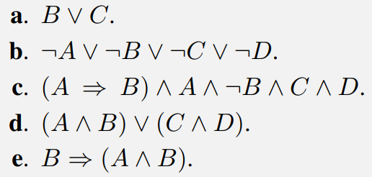

**Exercise 2:**

Decide whether each of the following sentences is valid, unsatisfiable, or neither. Verify your decisions using truth tables or the equivalence rules of Figure 7.11.  
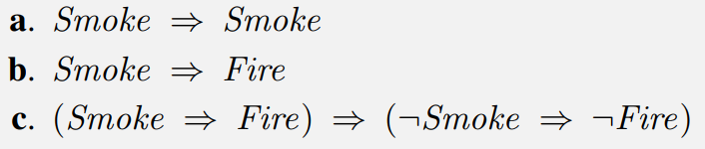 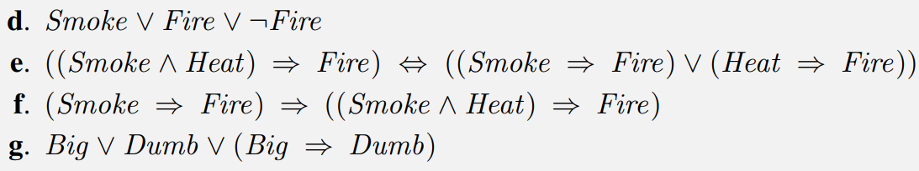

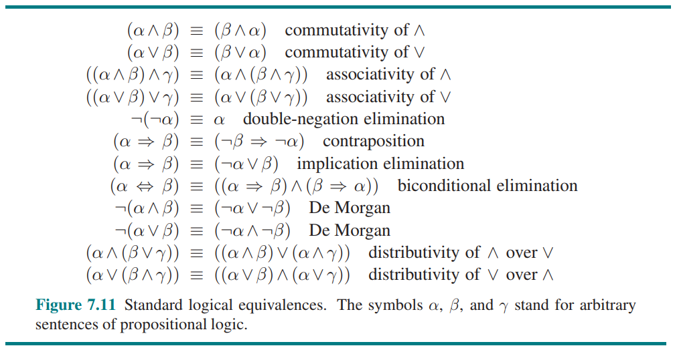

**Exercise 3:**

Which of the following are correct?

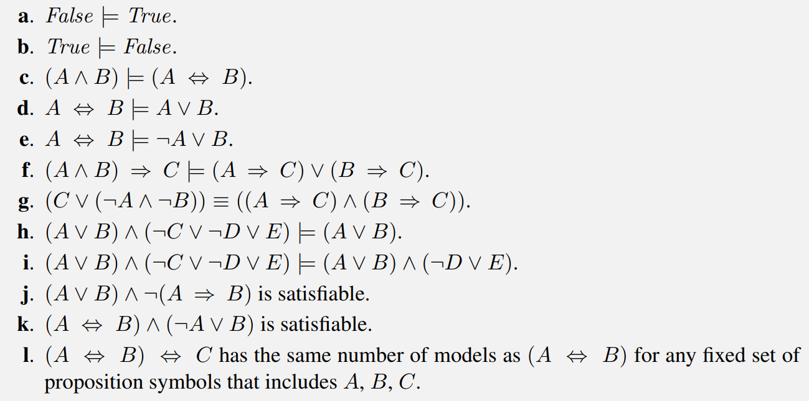

**Exercise 4:**

Consider a vocabulary with the following symbols:  
Occupation(p, o): Predicate. Person p has occupation o.  
Customer(p1, p2): Predicate. Person p1 is a customer of person p2.  
Boss(p1, p2): Predicate. Person p1 is a boss of person p2.  
Doctor, Surgeon, Lawyer, Actor: Constants denoting occupations.  
Emily, Joe: Constants denoting people.  
Use these symbols to write the following assertions in first-order logic:  
**a**. Emily is either a surgeon or a lawyer.  
**b**. Joe is an actor, but he also holds another job.  
**c**. All surgeons are doctors.  
**d**. Joe does not have a lawyer (i.e., is not a customer of any lawyer).  
**e**. Emily has a boss who is a lawyer.  
**f**. There exists a lawyer all of whose customers are doctors.  
**g**. Every surgeon has a lawyer.

**Exercise 5:**

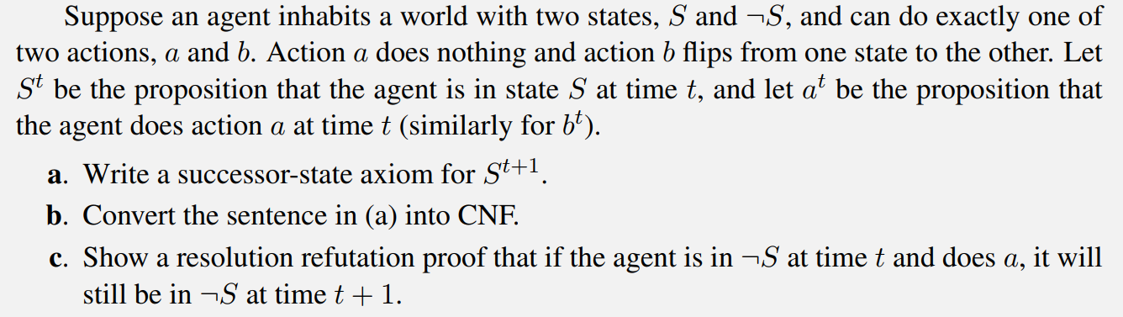

**Exercise 6:**

